BUSINESS ANALYSIS AND VALUATION

BROKERAGE AND FINANCIAL ADVISORY INDUSTRY

Gaurav M | 2022B3AA0587G
Sidhant Patnaik | 2022B3A10297G
Aryan Singhal | 2022B3A70204G
Shubham Sahoo | 2022B3A70628G
Girish | 2022A1PS1441G
Arrush Nair | 2022B3AA0468G

BITS PILANI , K.K BIRLA GOA CAMPUS
Course: Business Analysis and Valuation (ECON F355)
Instructor in Charge: Prof. Mohit Kumar

ACKNOWLEDGEMENT

We would like to express our heartfelt gratitude to Professor Mohit Kumar, our instructor for the course Business Analysis and Valuation, for his invaluable guidance and support throughout this project. His insightful lectures and constructive feedback have greatly enriched our understanding of the subject and provided us with the tools to approach this project analytically and comprehensively.
We are also thankful to our peers and colleagues for their collaboration and constructive discussions, which played a vital role in refining our ideas and methodologies.
Lastly, we thank our institution for providing access to essential resources and a conducive learning environment, enabling us to complete this project successfully.
Thank you to everyone who contributed, directly or indirectly, to the completion of this project.

INDEX

Sr No. | Topic | Page No.
1 | Introduction | 4-5
2 | Porter’s Five Forces | 5-7
3 | Porter’s Generic Competitive Strategy | 7
4 | BCG Matrix | 8-10
5 | SPACE Analysis | 11-15
6 | Blind Spot Analysis | 15-17
7 | PESTEL Analysis | 17-18
8 | SWOT Analysis | 19-22
9 | External Auditing of Company’s D&A Methods | 22
10 | Ratio Analysis | 23-29
11 | Balanced Scorecard | 29-32
12 | Beta | 32
13 | Cost of Capital | 33-34
14 | Business Valuation | 34-36
15 | Relative Valuation | 37-40
16 | References | 40-41

Introduction
The brokerage and financial services industry firms are crucial intermediaries in financial markets. They provide liquidity in marketplaces, facilitate price discovery, and execute trades. Brokerage firms allow investment in global financial markets, bringing buyers and sellers together, thus allowing investors to be well-diversified and properly manage associated risks.

Historically, most brokerage firms had a traditional model that charged a commission on each trade executed and served as advisors and intermediaries to their clients. Full-service brokerages provide an extensive service menu, including market research, personalised investment advice, portfolio management, and wealth planning. These firms, however, mostly focused on serving institutional investors and high-net-worth individuals, marrying professional financial expertise with relationship-based services.

Over the last few decades, the brokerage landscape has fundamentally changed because of rapid technological change, shifting investor preferences, and changing regulatory environments. The Internet and mobile technology have transformed how trading is conducted and are now omnipresent for retail investors. Online and discount brokerages have grown widely with low-cost or commission-free trading, easy interface, and online real-time market access.

Motilal Oswal Financial Services Ltd.
Motilal Oswal Financial Services Ltd. (MOFSL) is a diversified financial services company with several business operations, including wealth management, retail and institutional broking, asset management, investment banking, private equity, home finance and much more. Motilal Oswal Financial Service Limited has a wide range of products for individual and institutional investors, including mutual funds, equity, derivatives, commodities, and portfolio management services.

Prudent Corporate Advisory Services Ltd.
Prudent Corporate Advisory Services Ltd is in the financial services industry, focusing on distribution and advisory services. It provides mutual funds, insurance, and a host of other financial products to individual and business/ institutional clients. The company gains prominence because of its robust distribution network and client-centric approach.

Angel One Ltd.
Angel One Ltd. was known earlier as Angel Broking and is one of India's leading retail stockbroking firms. Angel One offers diverse investment and trading solutions regarding stocks, mutual funds, commodities, and derivatives. It is highly facilitated on its technologically advanced trading platform and user-friendly mobile app. Portfolio management advisory and margin trading facilities are other services for retail investors nationwide.

Porter’s Five Forces
- Rivalry among existing Firms
The following two factors can determine the degree of rivalry among existing firms within any industry-:
- Industry Growth Rate -: The Compound Annual Growth Rate (CAGR) for the Indian brokerage and financial advisory industry over the past five years is about 20-25%. This data has been derived from the average of the top 20 firms in this industry. Since the industry is growing fast, there may be no desire for competition to grab marketplace share from one another.
- Concentration and Balance of Companies-: The Indian brokerage and financial advisory industry is characterized by a combination of concentration and stability throughout distinct corporations. Discount brokers like Zerodha, Upstox, and Groww have captured a giant portion of the marketplace, mainly amongst retail buyers, due to their low-price buying and selling models and tech-pushed structures.
- Threat of New Entrants
- The danger of new entrants into the firm and brokerage industry is mild to moderate. On the one hand, the rise of digital structures and the low-fee version popularized by using reduced rate brokers like Zerodha has decreased admission to barriers, encouraging fintech startups to enter the marketplace like CRED is trying to enter the broking services.
- However, established buyers still have strong brand reputations, big customer bases, and deep economic assets, making it hard for green humans to gain marketplace share.
- Additionally, factors such as stringent regulatory requirements, the need for sturdy cybersecurity measures, and the desire to provide whole customer service further increase the complexity and price of getting into the market.
- Threat of Substitute Products
- Automated investment platforms-: The rise of automated investment structures. Creates a new set of risks for standard brokerage services. These systems provide algorithm-driven, cost-effective portfolio manipulation, making them attractive to customers seeking passive control options.
- Direct Mutual Fund Platforms: Platforms that allow direct investment in mutual funds without brokerage intermediaries have gained popularity. They offer lower prices and can steer clients away from traditional agents.
- Cryptocurrency exchanges: Dedicated exchanges and buying and selling programs with growing interest in cryptocurrencies enable traditional stock and commodity markets for customers looking to diversify or discover assets for another; those systems offer a compelling alternative, perhaps drawing interest away from traditional retail.
- Bargaining Power of Buyers
The following factors can determine the bargaining power of buyers in any industry market -:
- Price Sensitivity: Consumers in the packaging company exhibit excessive payment sensitivity due to the availability of many cheap and discounted options. Many companies offering competitive rates and low costs encourage merchants to look for the most cost-effective answer. This sentiment forces retail companies to be competitive in price and consistently offer paid offers to retain their clients.
- Relative Bargaining Power of Buyers: The bargaining power of consumers has accelerated due to the wide variety of choices available. Many auction companies offer similar products, and the ease of switching between them provides excellent value to their clients. This increased choice and competition enables customers to negotiate higher terms, request additional services, and call for higher-quality support from auction companies.
- Bargaining Power of Suppliers
- Technological Advantage: Providers of essential technologies, including trading structures, marketplace statistics vendors, and cybersecurity solutions, hold superb bargaining energy. Retail corporations increasingly rely upon these era solutions to allow green advertising and actual-time consumption. Because these suppliers provide fundamental offerings frequently wanted with confined options, they can considerably impact pricing and terms.
- Impact on records providers: Provision of marketplace information, analytics and analytics tools Data providers have excellent trading strength because of the character and importance of their function. Brokerages need accurate marketplace records to determine trades, make well-timed choices, and offer treasured insights. The precise nature of these information operations means that stores can set high expenses and impose aggressive phrases, affecting auction organisations’ running expenses.
- Compliance provider vendors: Suppliers who provide compliance, felony, and audit offerings also have greater bargaining energy. It is vital for auction organizations to conform to monetary regulations to avoid consequences and ensure efficiency. Given the complexity and significance of those responsibilities, highbrow property providers can affect manufacturers at incredible expense and reinforce robust conditions, which reflects the relevant function they play in retaining industry standards.
Porter’s Generic Competitive Strategy
- Cost Leadership - In the brokerage enterprise, value leadership has become a crucial aggressive strategy, specifically with the upward thrust of bargain brokerage companies. Cost leaders’ recognition of presenting trading services at decreased expenses compared to standard complete-service agents using minimizing operational charges through generation-pushed efficiencies and streamlined tactics. Discount agents like Zerodha and Upstox exemplify this technique by leveraging advanced buying and selling systems and automation to lessen fees and bypass the savings to customers through lower costs and commissions.
- Differentiation - Differentiation in the brokerage industry includes providing price propositions that set companies apart from their competitors beyond simply pricing. Full-carrier agents such as ICICI Direct and HDFC Securities must differentiate through complete research and advisory offerings, personalized portfolio management, and massive investment alternatives, including equities, derivatives, mutual price ranges, and established products. They have positioned themselves to provide excessive enjoyment with expert financial steerage and robust customer service. In contrast, tech-savvy brokers like Zerodha and Upstox vary with better, user-friendly trading systems, advanced features that include algorithmic trading gears, and smooth mobile experiences. The brokerages invest in the new age and offer precise functionalities to cater to tech-savvy buyers looking for convenience and performance.

BCG Matrix
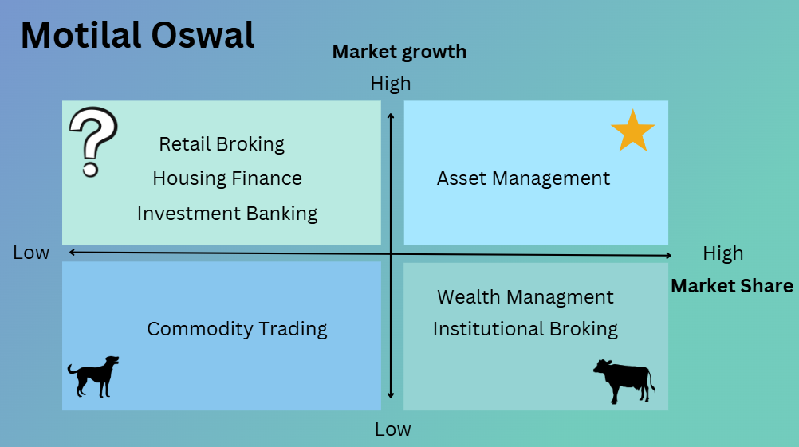
Motilal Oswal
- Asset management:
Market Growth Rate: 18% and Market Share: 35%
- Retail Broking
Market Growth Rate: 20% and Market Share: 2.5%
- Housing finance
Market Growth Rate: 18% and Market Share:4%
- Investment Banking
Market Growth Rate: 15% and Market Share: <2%
- Institutional Broking
Market Growth Rate: 10% and Market Share: 5%
- Wealth management
Market Growth Rate: 10% and Market Share:12%
- Commodity Trading
Market Growth Rate: 5% and Market Share: 6.9%

Angel One
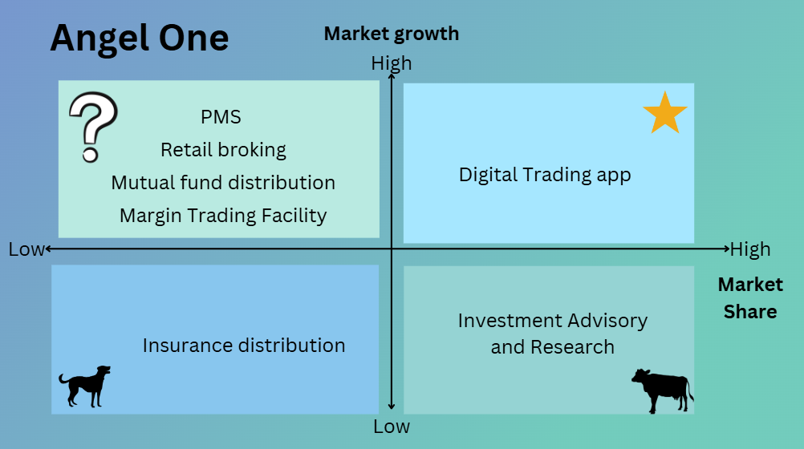

- Digital Trading app
Market growth rate: 20% and Market share: 25%
- Retail Broking
Market growth rate:20% and Market share:15%
- Margin Trading Facility
Market growth rate: 15% and Market share: 8%
- PMS (Portfolio management services)
Market growth rate: 12% and Market share: 2%
- Insurance distribution
Market growth rate: 8% and Market share: 5%
- Mutual fund distribution
Market growth rate: 15% and Market share: 15%
- Investment advisory and research
Market growth rate: 10% and Market share: 10%

Prudent Corporate Advisory Services
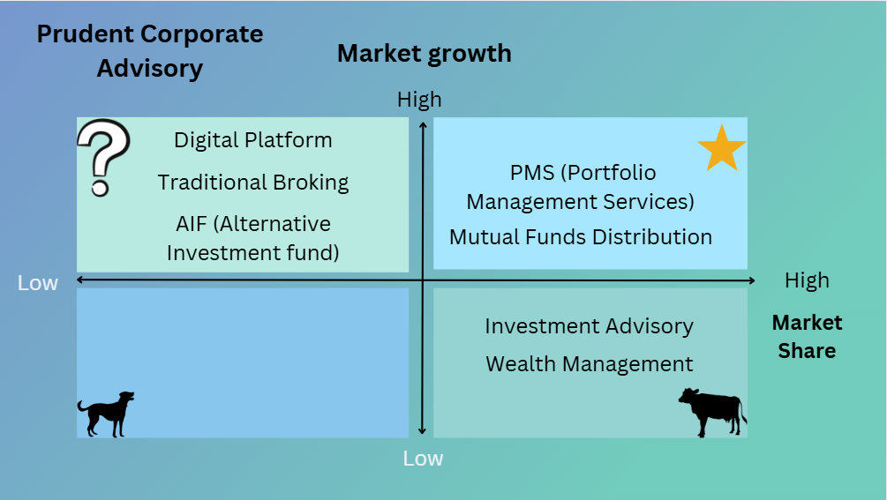

- Mutual Fund distribution
Market growth rate: 15% and Market share: 25%
- Wealth management
Market growth rate: 10% and Market share: 12%
- Traditional broking
Market growth rate: 20% and Market share: <2%
- AIF (Alternative investment fund)
Market growth rate: 15% and Market share: 5%
- Digital platform
Market growth rate: 20% and Market share: 3%
- PMS
Market growth rate: 12% and Market share: 15%
- Investment advisory
Market growth rate: 10% and Market share: 12%

SPACE Analysis
Motilal Oswal Financial Services Ltd.

Dimension | Factor | Score | Description
Competitive Advantage | Brand Reputation | -2 | Motilal Oswal is well-known in the financial services sector but faces competition from HDFC and ICICI.
 | Market Share | -3 | Large and diverse client base, including retail investors, institutions, and high-net-worth individuals.
 | Customer Loyalty | -3 | Investments in technology to enhance platforms attract tech-savvy clients.
 | Technological Edge | -4 | Significant investments in technology improve trading platforms and online services.
Environmental Stability | Economic Conditions | -3 | Business is tied to economic cycles, but India's growing economy provides some stability.
 | Market Volatility | -4 | High volatility due to market risks, regulatory changes, and competition.
 | Regulatory Framework | -3 | It is a well-regulated sector, but frequent updates require adaptability.
Financial Strength | Profitability | +5 | Healthy profit margins supported by diversified revenue streams.
 | Liquidity | +4 | Solid liquidity ratios ensure short-term obligations can be met.
 | Capital Base | +5 | A strong capital base contributes to financial stability.
 | Cash Flow | +4 | Steady cash flow ensures operational flexibility and financial health.
Industry Attractiveness | Growth Potential | +5 | Significant growth potential as more retail investors enter the market.
 | Regulatory Environment | +3 | Stable, though regulatory oversight requires companies to remain compliant.
 | Innovation & Technology | +4 | The rapid adoption of new technologies is essential for staying competitive.

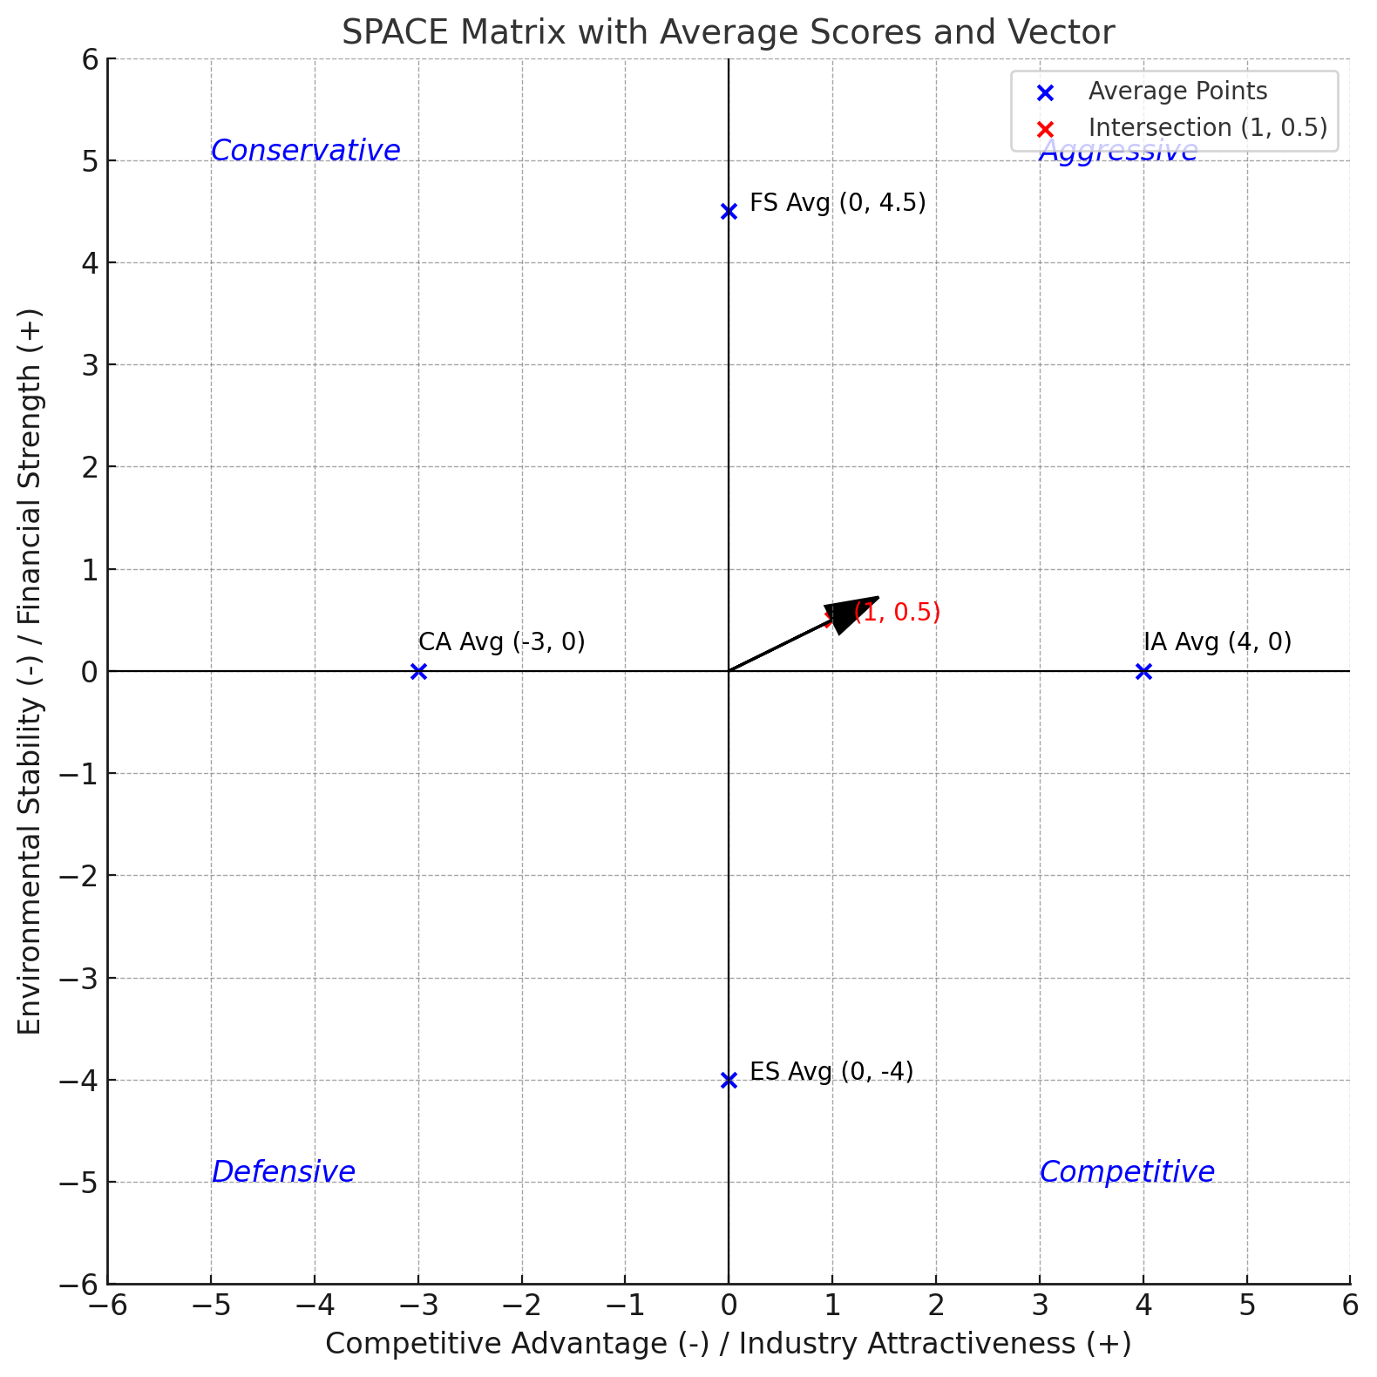
Given the scores, the vector is likely pointing toward the upper right quadrant, suggesting an Aggressive strategy type for MOFSL.
Angel One Ltd.
Dimension | Factor | Scores | Description
Competitive Advantage | Brand Reputation | -2 | Motilal Oswal is well-known in the financial services sector but faces competition from HDFC and ICICI.
 | Market Share | -3 | Large and diverse client base, including retail investors, institutions, and high-net-worth individuals.
 | Customer Loyalty | -2 | Investments in technology to enhance platforms attract tech-savvy clients.
 | Technological Edge | -2 | Significant investments in technology improve trading platforms and online services.
Environmental Stability | Economic Conditions | -3 | Business is tied to economic cycles, but India's growing economy provides some stability.
 | Market Volatility | -3 | High volatility due to market risks, regulatory changes, and competition.
 | Regulatory Framework | -4 | It is a well-regulated sector, but frequent updates require adaptability.
Financial Strength | Profitability | 4 | Healthy profit margins supported by diversified revenue streams.
 | Liquidity | 3 | Solid liquidity ratios ensure short-term obligations can be met.
 | Capital Base | 4 | A strong capital base contributes to financial stability.
 | Cash Flow | 3 | Steady cash flow ensures operational flexibility and financial health.
Industry Attractiveness | Growth Potential | 5 | Significant growth potential as more retail investors enter the market.
 | Regulatory Environment | 3 | Stable, though regulatory oversight requires companies to remain compliant.
 | Innovation & Technology | 4 | The rapid adoption of new technologies is essential for staying competitive.

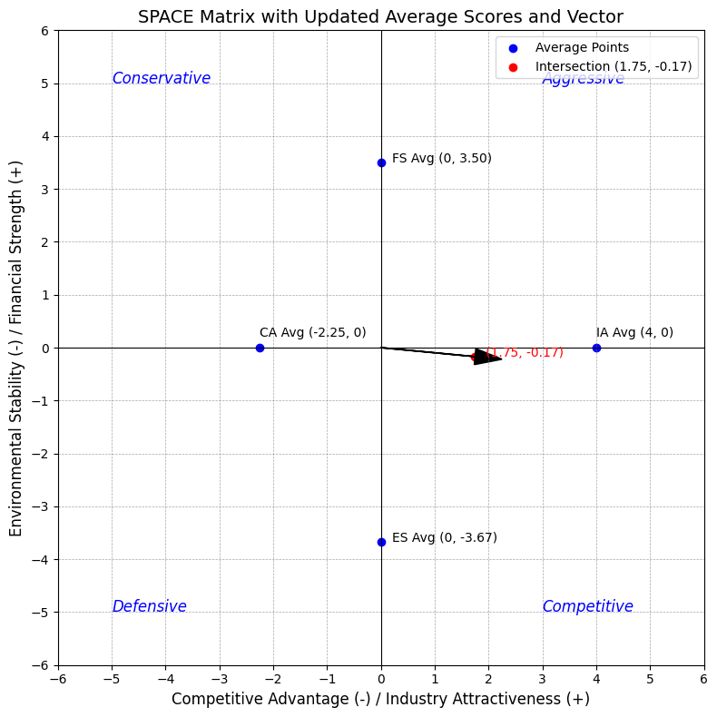
The SPACE Matrix for Angel One Ltd has been plotted. The vector, starting from the origin (0, 0) and pointing towards the intersection point at (1.75, -0.17), suggests a competitive strategy.
Prudent Corporate Advisory Services Ltd.

Dimension | Factor | Scores | Description
Competitive Advantage | Brand Reputation | -3 | It is a strong brand but not a dominant force in the broking industry.
 | Market Share | -2 | Small market share but steadily growing, especially in the mutual fund space.
 | Customer Loyalty | -3 | Customers enjoy the personal advisory services, hence good brand loyalty.
 | Technological Edge | -2 | It has invested in a good trading platform but is smaller than Zerodha or Angle One.
Environmental Stability | Economic Conditions | -3 | India’s steady economic growth is due to rising retail investors in mutual funds.
 | Market Volatility | -4 | Investors pull out money during market downturns and don't use advisory services either.
 | Regulatory Framework | -3 | Continuously changing regulatory frameworks need adaptability to survive.
Financial Strength | Profitability | 4 | Has consistent revenue growth with a good operating margin.
 | Liquidity | 3 | Low debt levels have caused enhanced liquidity. High current ratio.
 | Capital Base | 3 | The capital base supports operational expansion but is smaller than competitors.
 | Cash Flow | 4 | Steady cash flow. Growth in the mutual fund industry contributes to cash flow.
Industry Attractiveness | Growth Potential | 4 | High growth since retail investors are moving from traditional investments like fixed deposits to mutual funds
 | Regulatory Environment | 3 | Stable, with SEBI introducing new laws to increase transparency
 | Innovation & Technology | 3 | The adoption of digital means is necessary to stay competitive.

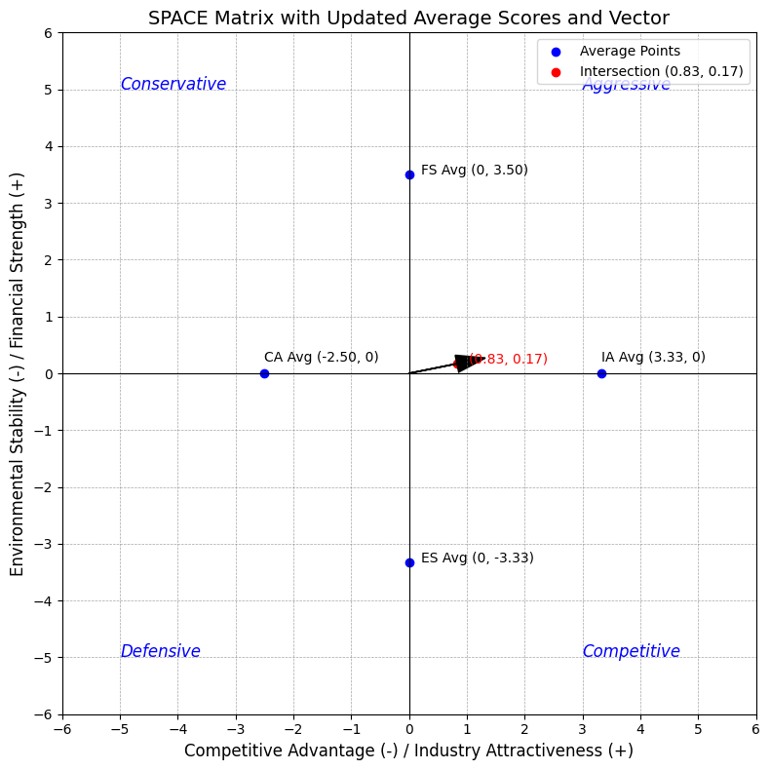
The SPACE Matrix for Prudent Corporate Advisory Services Ltd has been plotted. The vector originates from the origin (0, 0) and points towards the intersection at (0.83, 0.17). This position indicates a balanced strategy but leans slightly toward an Aggressive strategy.
Blind Spot Analysis

 | Motilal Oswal | Angel One | Prudent Advisory
Identifying Cognitive Biases  - Overconfidence Bias  - Confirmation Bias | Focusing on HNI clients more than retail clients.  Slowdown in new account openings due to competition by other brokers | Scaling of their tech-driven platform without realizing market saturation.  Pushing for aggressive customer acquisition without customer satisfaction | Strong foothold in mutual fund distribution, threat of new entrants.  Traditional broking instead of integrating digital platforms.
Uncovering assumptions  - Growth assumption  - Technology adoption | Market saturation or macroeconomic downturn  Need for a digital platform for tech-savvy investors. | Increase of digital and financial literacy with few regional exceptions  Missing out on small, less tech-savvy investors. | Assumes growth of mutual fund investments for the future, but market saturation can occur.  Missing out on the older generation, who are less tech-savvy and slow to adopt app-based advisory services.
Monitoring External changes  - Regulatory Changes  - Market Trends  - Competitive Landscape | SEBI mandates specific margin rules  Rise in passive investing  (MF and ETFs)  Discount brokers like Zerodha and Digital brokers like Zerodha, Angel One, Groww | SEBI mandates specific margin rules  Rise in passive investing  (MF and ETFs)  Discount brokers like Zerodha. | SEBI caps distribution fees on mutual funds.  Rise in passive investing.  (MF and ETFs)  Digital brokers with investment advisory services like Motilal Oswal and Angel One.
Evaluating Competitors  - Competitor Analysis  - Benchmarking | Zerodha, Upstock, and Groww have digital platforms.  Onboarding time, tech adoption, customer satisfaction | Zerodha’s dominance in zero brokerage fees.  Gaps in user experience and metrics for operational efficiency | Prudent advisory focuses on independent financial advisors, while other advisory services have direct mutual fund distribution.  Customer acquisition costs and client retention rates
Scenario planning  - Economic downturn  - Technological disruption  - Regulatory Shifts | If less money comes from retail investors, focus on wealth management and advisory services.  AI-powered trading tools and AI financial-advisors  SEBI regulations regarding brokerage fees. | If retail investors' trading volumes decrease, focus on advisory services.  Rise of Decentralised Finance (DeFi) trading platforms.  SEBI regulations regarding brokerage fees. | If retail investors' trading volume decreases, they should expand to fixed-income markets.  Rise of AI financial advisors  SEBI regulations regarding commission on mutual fund distribution.
Diverse perspectives | Data analysts and tech experts for diverse opinions about the future of markets | Regional leaders should study patterns of investing across the country. | Tech development team, for their opinion to invest in AI and automation.
Learning from past mistakes  - Past Failures  - Customer feedback | Aggressive price reduction didn't work as expected.  Customers are having issues with Motilal Oswal’s app. | Faced problems with user retention.  Customers have problems placing orders during times of high trading volume. | Problems during the launch of their investment app  Customer complaints about lack of transparency in fund selection.

PESTEL Analysis

Political:
A stable political environment plays a key role in the brokerage and financial advisory industry by attracting foreign investments, boosting market liquidity and supporting economic growth. This results in more investors participating in the market. Various initiatives like Pradhan Mantri Mudra Yojana, Atmanirbhar Bharat Abhiyan, and Jan Dhan Yojana by the current ruling political party expand the investor's base in stock and commodity exchanges. Increasing short-term capital gain tax and long-term capital gain tax reduces investors' returns, resulting in less market participation.

Economic:
Economic conditions play a significant role in the brokerage and financial advisory industry due to various variables like interest rate, inflation rate, GDP growth, etc. Institutional and other investors' market participation depends on the interest rates and bond yields. Other factors are the unemployment rate and consumer spending, which shape the excess income of retail investors and can impact their market participation.

Social:
In India, market participation has increased significantly over the past half-decade for various reasons. Cultural shifts like increased use of digital platforms and online platforms for trading during the pandemic. Due to this culture change, the younger generation got a chance to participate in the market. The sudden demand for SIPs and SWPs market sentiment was positively affected by excess cash pumped into the market, resulting in investors' increased market participation.

Technological:
With the rise in mobile applications and online platforms for trading, people can manage and access their portfolios at their convenience. Digital payment systems like UPI have simplified transaction processes, which encourage retail investors to participate in the market.

Environmental:
Global focus on sustainable investments and ESG-Environmental, Social and Governance.
Increase awareness of climate changes and environmental risks. People participate in commodity trading and prefer green stocks. Also, lenient tax policies and changes in rules and regulations affect the stock and commodity prices, creating market sentiments and more market participation.

Legal:
They are securitized by the regulation body SEBI, the Securities and Exchange Board of India. It mainly focuses on transparency in market dealings, protection of investors, and fair trading practices. Strict regulations regarding insider trading, anti-money laundering, and KYC (Know Your Customer) maintain compliance and market integrity.

SWOT Analysis
Motilal Oswal Financial Services
Strength | 1. Diverse Product Portfolio  Offering a wide range of products, including trading platform, mutual funds, portfolio management schemes, and financial advisory, mitigates the risk.  2. Research Team  The company is known for its in-depth financial research, providing investors with high-quality market insights and recommendations.  3. Brand Reputation  With decades of experience, the company has established a trusted brand reputation.
Weakness | 1. Technology Gaps  The company could not fill the industry's fast-growing technology gap through its application and online platforms.  2. Dependency on market volatility  The company's revenue model is highly based on market performance, which makes the company more vulnerable during market slowdowns and economic downtrends.  3. High Brokerage Fees  High brokerage fees of the company result in cost-sensitive customers not using the services.
Opportunities | 1. Growing Retail Investor Base  Increasing financial literacy across the country increases the number of participants in the market, and the company could use its robust advisory feature to increase its customer base.  2. Digital Transformations and AI Tools  By exploiting AI tools, advisory tools and analytics can be optimized, and customer experience can be enhanced.  3. International market and NRI focus  Expanding services to the international market and diversifying the revenue sources. NRI participation is increasing in the Indian market due to favourable economic conditions, which can be used to expand the customer base.
Threats | 1. Fierce Competition  Discount brokers, which offer lower brokerage or zero fees, provide significant challenges to the company.  2. Regulatory Changes  Constant changes in SEBI and taxation policies interrupt the company's operation, resulting in higher compliance fees.  3. Market Uncertainty  Reducing the investor’s participation due to unstable market conditions and unpredictable global activities.

Angel One:
Strength | 1. Low-Cost brokerage model  The company is known for its competitive pricing and for attracting cost-sensitive customers.  2. Large Retail Client Base  15.25% market share in terms of active clients in the market, contributing stable revenue growth.  3. Strong Digital ECOSystem  The company has made significant investments in technology for its application and online platform to provide a user-friendly experience for investors.
Weakness | 1. Limited products for premium clients  The company only focuses on retail clients and does not offer unique products like PMS, resulting in losing HNIs as their customers.  2. Dependency on technology  The company is highly dependent on technology, which could make it vulnerable to tech disruptions and cybersecurity threats that impact clients' trust.  3. Research Capabilities  The research capabilities of the company are less than that of full-service brokers.
Opportunities | 1. Expanding Retail Investor Base  Increasing financial literacy across the country increases the number of participants in the market and can attract digitally empowered youth.  2. Rise of AI  Incorporating AI in their platforms with advanced analytics and personalised insights can give the company leverage over others.
Threats | 1. Intense Competition in low brokerage services  Players like Groww and Zerodha are the most significant competition, which drives a price war among them.  2. Regulatory Pressure  Constant changes in SEBI and taxation policies interrupt the company's operation, resulting in higher compliance fees.  3. Economic Slowdown and Market Pressure  Reducing the investor’s participation due to unstable market conditions and unpredictable global activities.

Prudent Corporate Advisory Services:
Strength | 1. Wide Distribution Network  The company has a strong presence in the country, leveraging its strong network of sub-brokers and distributors to offer financial products like insurance, mutual funds and many more.  2. Focus on Mutual fund distribution  As one of the largest mutual fund distributors in the country, the company has benefited from growing demand for investments in the market via SIPs.  3. Client Relationship  The company’s personalized finance planning and client-centric approaches build long-term trust and loyalty from the clients.
Weakness | 1. Dependency on Mutual Funds  82.4% of the company's revenue comes from mutual fund product distribution, making it more vulnerable because of one industry-specific.  2. Brand Recognition  The company lacks the widespread brand recognition necessary to acquire a larger market share.  3. Technology Adoption  The company has a technology gap compared to other fintech competitors in terms of integrating advanced tools on their platforms.
Opportunities | 1. Financial Awareness  Increasing financial literacy across the country increases the number of participants in the market and can attract stable-income clients to invest in mutual funds and insurance policies.  2. Diversification into new products  Several other financial products, like alternative investment solutions, digital lending and many more, can be provided.  3. Collaborations with Fintech companies.  Collaborating with fintech companies can enhance the company's technological capabilities, attract younger customers, and optimize distribution channels.
Threats | 1. Regulatory Changes  Constant changes in SEBI and taxation policies interrupt the company's operation, resulting in higher compliance fees.  2. Aggressive Industry Competition  Low-cost distribution models offered by fintech competitors and direct mutual fund platforms provide a significant risk to the company as they have traditional distribution models.  3. Market Dependency  Reducing the investor’s participation due to unstable market conditions and unpredictable global activities.

External Auditing of Company’s D&A Methods
All publicly listed companies need to be transparent and provide any beneficial information of importance to the stakeholders and the public. This publicly available information can be manipulated inside the company to show itself as prosperous and attract wealth and interest. To evaluate whether the information and data provided by the company are True and Fair, and not biased, external auditing companies verify the information.
For the common public to check if the information provided is true and fair, one way to examine this is by checking the number of times the company is changing their external auditors or if the auditors are pulling out.
There can be several reasons for Auditor change,
Some of them are:
- Conflict Over Audit Findings
- Audit Opinion Shopping
- Avoidance of Scrutiny
- Independence Concerns
- Potential Mismanagement or Fraud
Any of the above reasons can indicate continuously changing auditors, further highlighting that the company doesn’t provide true and fair information.
In this case, for the following companies, we observe that auditors are not changing continuously and only changing to abide by the law that compels companies to change external auditors at regular intervals.
Current External Auditors:
- Motilal Oswal Financial Services Ltd. - Singhi & Co.
- Angel One Ltd. - M/s. S. R. Batliboi & Co. LLP
- Prudent Corporate Advisory Services Ltd. - M/s. Deloitte Haskins & Sells, Chartered Accountants
Depreciation And Amortization
- Motilal Oswal Financial Services Ltd. - Straight-Line Method (SLM)
- Angel One Ltd. - Straight-Line Method (SLM)
- Prudent Corporate Advisory Services Ltd. - Written Down Value (WDV), a small proportion (3.21%) of the assets are depreciated using the Straight Line Method (SLM)

Ratio Analysis
Financial ratio analysis is a strong tool for evaluating a company's financial performance and financial position in the market.

Liquidity Ratios:
Motilal Oswal Financial Services:
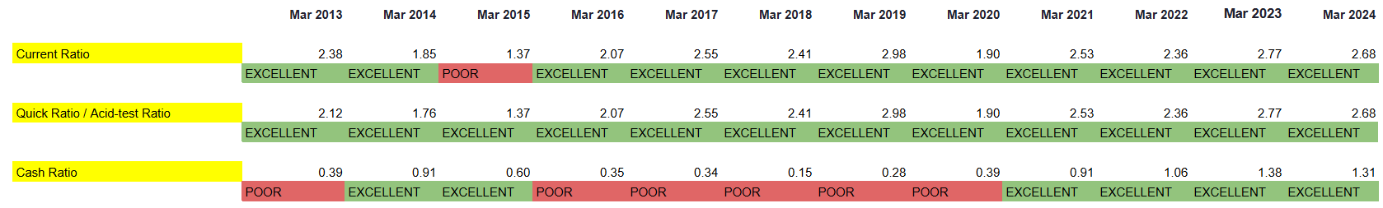

Angel One:
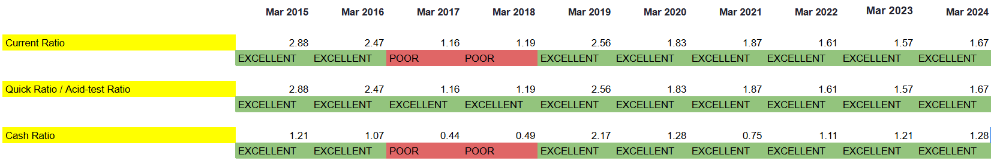

Prudent Corporate Advisory Services:
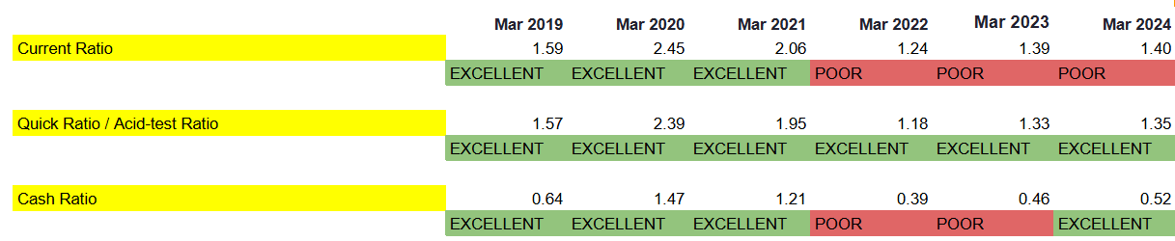
Averages:
Current Ratio: 1.5
Quick Ratio: 1
Cash Ratio: 0.5
Leverage Ratios:

Motilal Oswal Financial Services:
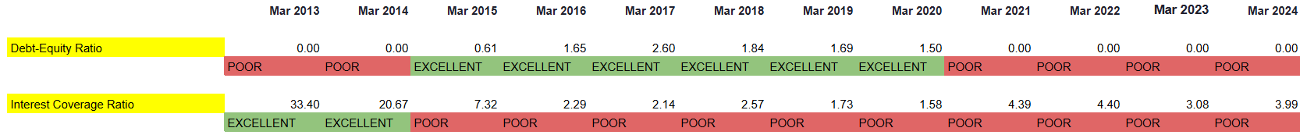

Angel One:
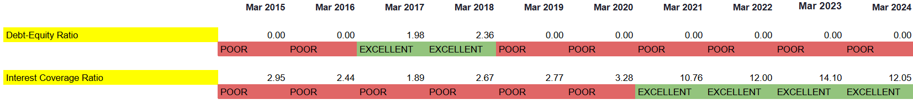

Prudent Corporate Advisory Services:
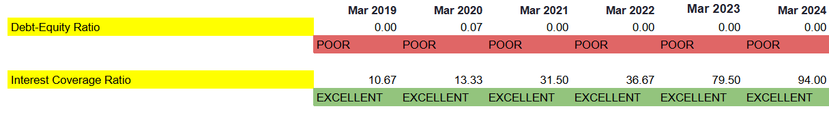

Average:
Debt-Equity Ratio: 0.1
Interest Coverage Ratio: 10

Activity Ratios:

Motilal Oswal Financial Services:
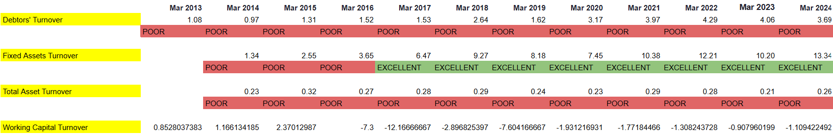

Angel One:
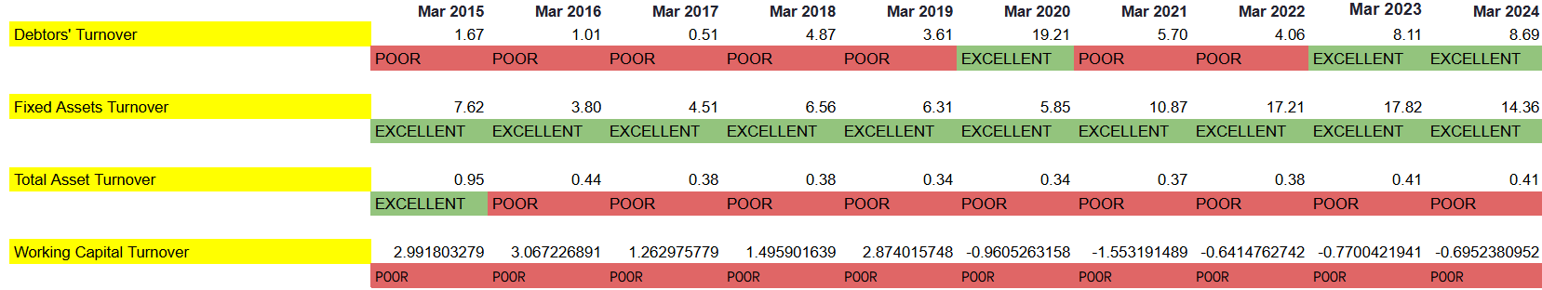

Prudent Corporate Advisory Services:
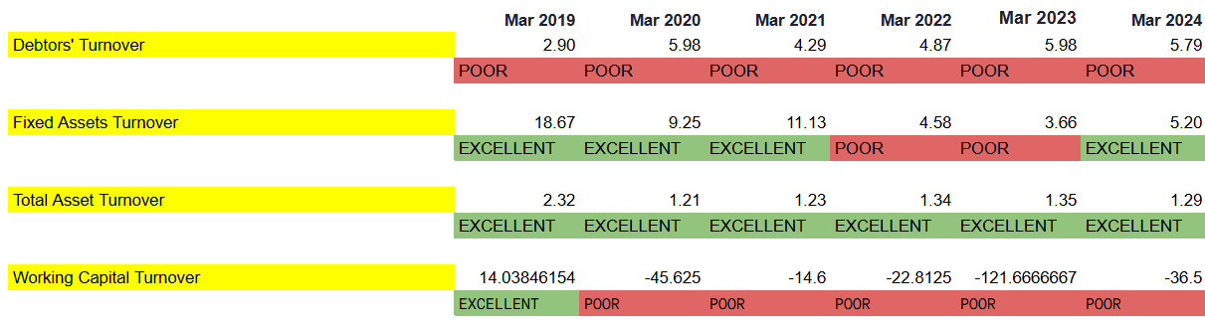
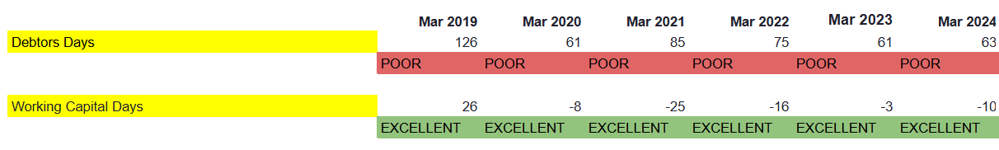
Averages:
Debtors’ Turnover: 6x
Fixed Asset Turnover: 5x
Total Asset Turnover: 0.5x
Working Capital Turnover: 6x
Debtors Days: 40
Working Capital Days: 45

Profitability Ratios:

Motilal Oswal Financial Services:

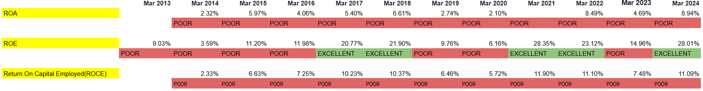

Angel One:

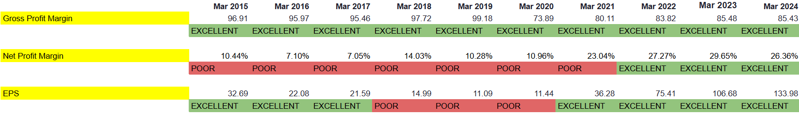

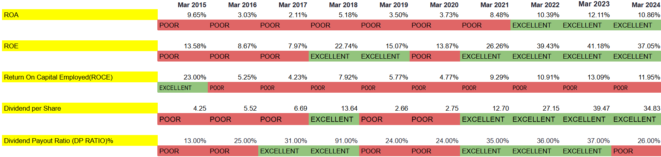

Prudent Corporate Advisory Services:
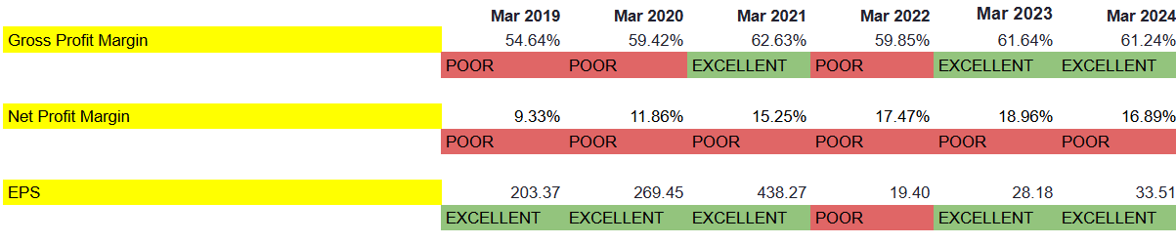

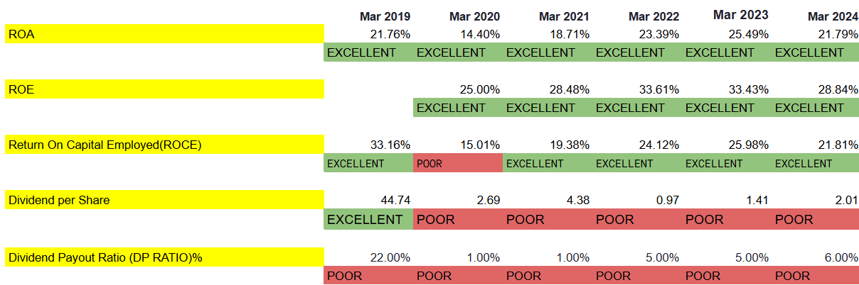
Averages:
PAT to EBIT: 70%
Gross Profit Margin(%): 60%
Net Profit Margin(%): 25%
Earnings per share: 20
Return on assets(%): 10%
Return on Equity(%): 15%
Return on Capital Employed(%): 18%
Dividend per Share: 10Rs.
Dividend Payout Ratio(DP RATIO%): 30%

Valuation Ratios:

Motilal Oswal Financial Services:

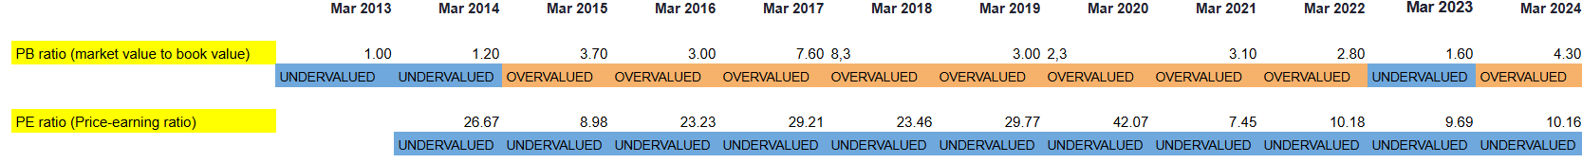

Angel One:
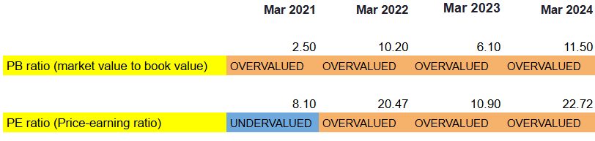

Prudent Corporate Advisory Services:
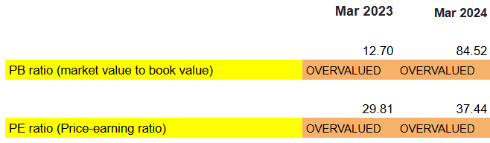

Averages:
Price to Book ratio(PB):2.48
Price to earning ratio(PE):10.02
*All ratios are calculated by making various assumptions, which may differ from the exact figures provided online.
Assumptions:
Screener Data is taken, and all assumptions are taken accordingly.
- Total revenue is taken sum of sales and other income
- COGS is taken as the sum of opening Inventory, material cost, and manufacturing Cost and subtracted from the Closing Inventory
- Shareholder's equity is the sum of Equity Capital and Reserves
- Total Equity is the sum of the Shareholder's equity and Non-controlling interest
- ROE is taken ratio of net income and shareholder’s equity
- Current Liabilities include short-term borrowings, advances from customers, trade payables, and other liabilities( other liabilities should be paid within 1 year, trade payables in 1 year )
- Current assets include trade receivables, short-term loans, other asset items, inventories, cash, and cash equivalents.
- Debt to Equity: Equity is taken to be shareholder's equity, and in debt, short and long-term borrowings and other borrowings are included)
- Operating Expense is the sum of Employee benefits and Interest Expense and Other Cost
- Total debt includes short and long-term borrowings
- Some ratios are directly imported from Screener.in which is specified on the right of the table.

Limitations:
- Difficulty in Comparison
Comparing the firms is difficult due to the difference in their business models, like Angel One’s digital focus compared to Prudent’s advisory-heavy model.
- Changes in Price Levels
The broking industry is very sensitive to market fluctuations and macroeconomic factors like interest rates and inflation data. While comparing the firms, there will be changes in depreciation values to the difference in the operating model, such as Motilal Oswal’s more traditional approach compared to Angel One’s digital approach.
- Differences in Definitions
Different companies use different accounting practices for reporting values like AUM, net margins and asset depreciation, leading to a difference.
- Static Nature of Ratios
The ratios derived from a specific point fail to capture some trends like Angel One’s rapid digitalisation. The static nature also fails to capture Prudent’s immediate changes in business strategy.
- Historical Focus
Ratios rely on past performance and don't accurately account for changes in dynamics in the future, such as the tech-driven shift of investors for Angel One and customers' preference towards mutual funds in the case of Prudent Advisory.
Balanced Scorecard
Prudent Corporate Advisory Services:

1. Financial Perspective
Objective | Key Metric | Target | Initiatives
Increase Revenue | Revenue Growth Rate | 18-20% YoY | - Expand reach by increasing partnerships with mutual fund providers.  - Focus on cross-selling insurance and mutual funds to existing clients.

2. Customer Perspective
Objective | Key Metric | Target | Initiatives
Increase Client Satisfaction | NPS Score | 85% or above | - Regularly collect client feedback to improve services.  - Offer personalized advisory sessions for premium clients.

3. Internal Process Perspective
Objective | Key Metric | Target | Initiatives
Enhance Operational Efficiency | Process Cycle Time | 15% reduction | - Implement workflow automation to streamline routine tasks in account processing.  - Invest in a CRM system to improve data tracking and reduce service bottlenecks.

4. Learning & Growth Perspective
Objective | Key Metric | Target | Initiatives
Increase Employee Training | Training Hours per Employee | 50 hours per year | - Regular training on investment strategies and financial products should be conducted.  - Launch leadership development for high-potential employees.
Angel One Ltd.

1. Financial Perspective
Objective | Key Metric | Target | Initiatives
Increase Revenue | Revenue Growth Rate | 20-25% YoY | - Focus on digital client acquisition and onboarding, especially in emerging markets.  - Expand offerings in derivatives and margin trading to attract active traders.

2. Customer Perspective
Objective | Key Metric | Target | Initiatives
Enhance Client Satisfaction | NPS (Net Promoter Score) | 85% or above | - Regular surveys and feedback loops for real-time service improvements.  - Create a dedicated customer experience team focused on issue resolution.

3. Internal Process Perspective
Objective | Key Metric | Target | Initiatives
Improve Operational Efficiency | Process Cycle Time | Reduce by 15% | - Implement Robotic Process Automation (RPA) in account processing and onboarding to cut wait times.  - Expand cloud-based infrastructure to support rapid scaling and minimize downtime.

4. Learning & Growth Perspective
Objective | Key Metric | Target | Initiatives
Enhance Employee Skills | Training Hours per Employee | 60 hours annually | - Conduct training on fintech innovations and analytics for better client service.  - Introduce leadership development programs for senior and mid-level managers
Motilal Oswal Financial Services Ltd.

1. Financial Perspective
Objective | Key Metric | Target | Initiatives
Sustain Revenue Growth | Revenue Growth Rate | 15-20% YoY revenue growth | - Deepen client penetration in underrepresented markets via digital channels.  - Expand offerings in mutual funds and structured products like AIFs to capture increasing wealth creation among Indian HNIs.

2. Customer Perspective

Objective | Key Metric | Target | Initiatives
Enhance Customer Satisfaction | Customer Satisfaction | 90% or above | - Launch the RISE super app to improve customer interface for brokerage, mutual funds, and wealth advisory.  - Establish a dedicated Customer Success Team to provide proactive advisory and monitor customer satisfaction.

3. Internal Process Perspective
Objective | Key Metric | Target | Initiatives
Streamline Operations | Process Cycle Time | 10% reduction in process cycle time | - Implement RPA in key back-office operations to speed up trade settlements and customer onboarding.  - Optimize and standardize account opening processes for quick turnaround.

4. Learning & Growth Perspective
Objective | Key Metric | Target | Initiatives
Enhance Employee Skills | Training Hours per Employee | 50 hours annually | - Develop specialized training programs on financial advisory, AI-driven analytics, and client management.  - Establish a Leadership Academy to foster management skills and future leadership.

Beta
Beta is the measure of volatility or risk of a stock as compared to the market, and it is represented by the Greek letter beta. Beta is used to assist the investor in knowing about the stock's risk profile and how much it will increase the risk of a portfolio. Types of Beta are as follows - :
- Historical Beta: Measures a stock's past sensitivity to the market movements using regression analysis between the stock's returns and market index returns. It is calculated as the slope of the regression line.
- Fundamental Beta: It estimates beta based on a company's financial and operational characteristics, like leverage or earnings volatility. A model is calculated using these factors.
- Bottom-Up Beta: estimated from beta averages of comparable companies' industry betas, adjusted for specific capital structure, using peer data reported publicly and leverage adjustments.
- Accounting Beta: Uses accounting statement information to measure the company's accounting profitability in relation to economic performance. The accounting beta can be calculated by running a regression of company earnings against the GDP or market-wide profitability trend.
For our cost of equity calculations, we have used the historical beta obtained from regressing the day-to-day stock returns of each company against the NIFTY 50 market index. This gives us the levered historical beta for each firm. We have also unlevered this beta to see the degree of leverage each company is operating on.

Cost of Capital
The cost of capital for a stock is the minimum rate of return that a company must earn to maintain profitability and offset the risk associated with the business. It's also the rate of return that investors can expect to gain from a company's stock. It is calculated by individually calculating the cost of debt and equity, then adding both weights.
The cost of debt is calculated by dividing the total interest expense of the company by its total debt and multiplying it by (1-Tax rate). On the other hand, capital cost is calculated using the CAPM formula.
The following assumptions have been considered while calculating the cost of capital for the respective companies :
- The Indian 10-year Government Bond has been considered as the risk-free rate.
- Total equity = Reserves + Equity Capital + Non-Controlling Interest
- Total Debt = Borrowings + Other Liabilities - Non-Controlling Interest
- Noncontrolling interest (NCI) is considered equity because it represents a portion of a company's equity ownership that the parent company does not own.
- Given Angel One’s market size, it will likely be rated A- category. Companies with these ratings typically have a credit default spread of 3%
- Given Prudent’s market size, it will likely be rated BBB or BBB- category. Companies with these ratings typically have a credit default spread of 3.5%.

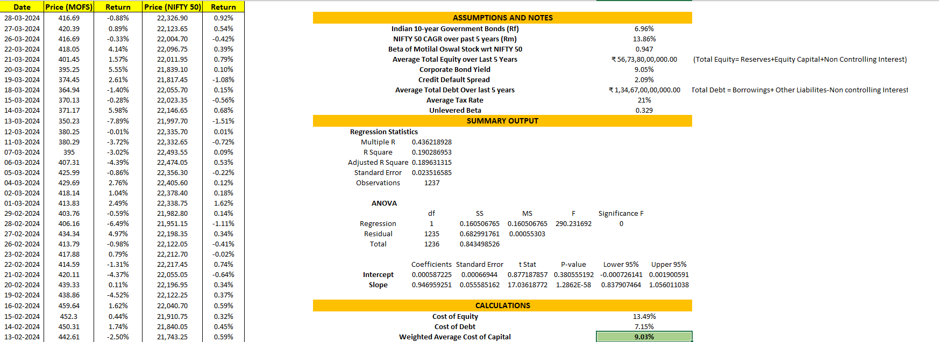
Motilal Oswal Financial Services Ltd.

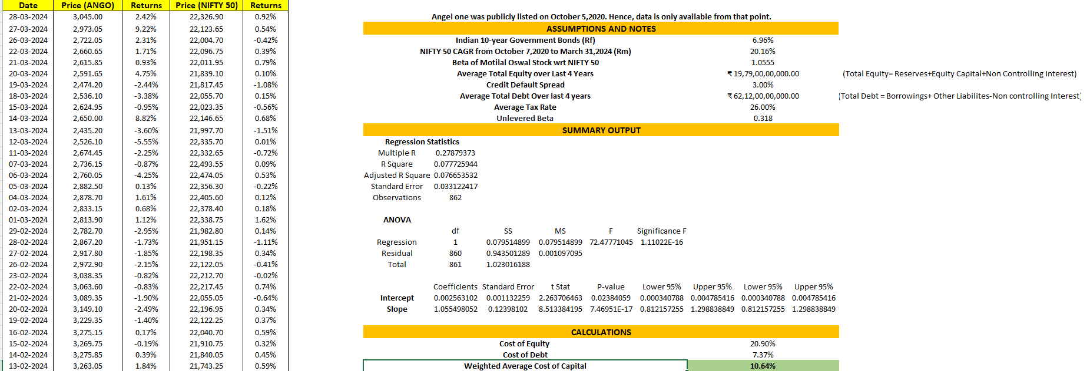
Angel One Ltd.

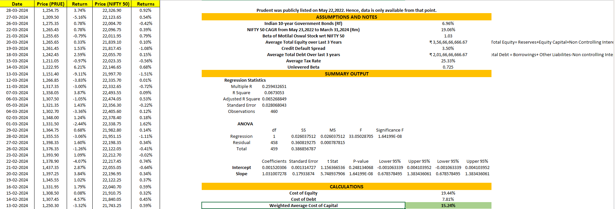
Prudent Corporate Advisory Services Limited

Business Valuation
Business valuation is the process of determining the economic value of a business or its fair market value. It involves analyzing a business's financial elements, such as assets, liabilities, revenue, and market conditions. There are various methods for valuing a business. Some of them are as follows -:
- Dividend Discount Model (DDM): This method values a company by discounting its expected future dividends to the present. For zero growth, dividends are constant, and the value is P=D/R​. It uses P=D1/(R−g) ​​for constant growth, where g is the growth rate. For differential growth, it has included varied growth rates over time accompanied with differences in the periods before turning towards a constant growth.
- Free cash flow model (FCF): This model calculates the present value of the free cash flows generated by the firm. The latter is, in general, defined as the residual for equity investors after accounting for both operating expenses and capital expenditures. Typically, there is often a differentiation between Free Cash Flow to the Firm (FCFF) and Free Cash Flow to Equity (FCFE), which are discounted by WACC or cost of equity, respectively.
- Contingency Claim Model: Also named real options valuation, in this method, a business will be valued by considering uncertain future opportunities as financial options. It uses option-pricing models (e.g., Black-Scholes) to assess the value of growth opportunities, flexibility, or strategic options in uncertain environments.
For our industry, we have used the free cash flow model. This is because the brokerage and financial advisory firms we have chosen do not pay significant dividends and have an average dividend payout ratio in the range of 5.33% to 33.33% and this cash flow to the investors is minimal and may not accurately represent the company’s ability to generate value.
The following assumptions and steps have been considered while calculating the Enterprise Value of the respective companies -:
- The discount rate used is the cost of capital of each company respectively.
- A two-step DCF model is used for valuation. For the first few years, where a company is growing with its own growth rate. After that, it is assumed that the company will achieve a sustainable growth phase after the high growth phase, attaining a growth rate around a long-term average GDP growth rate.
- The time period over which the discount and growth rate are considered is the same for each company, leading to different average GDP growth rates for different companies.
- The average GDP growth rate is adjusted for the pandemic as the economy slowed down during that period.
- Growth rate = ROE*(1-Retention Ratio)
- EBIT, Tax rate, Depreciation and CAPEX all grow at the growth rate.
- Tax rate is capped once it reaches 33-34%.
- Change in working capital does not follow any particular trend, so it is assumed to be constant for a few years.
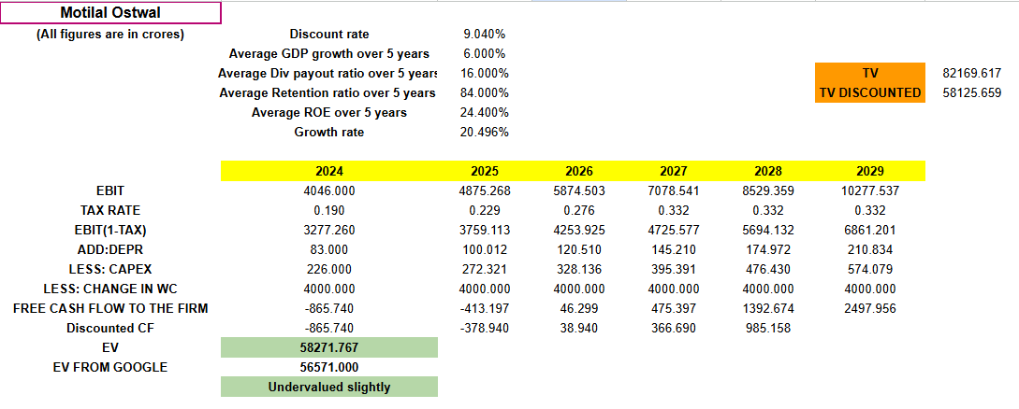
Motilal Oswal Financial Services Ltd.

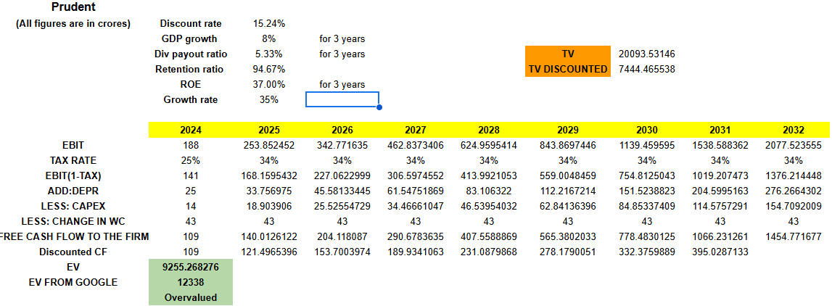
Prudent Corporate Advisory Services Ltd.

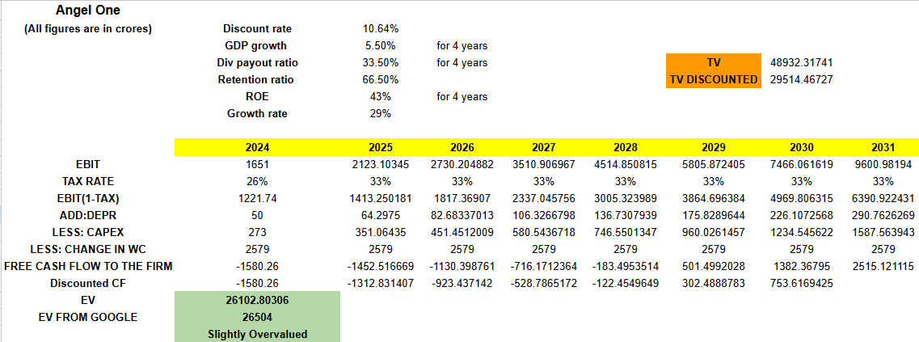
Angel One Ltd.

*2024 means values as on March 2024

Relative Valuation
Relative valuation is how we price our assets based on the pricing of similar assets in the market. This is done using a relative method, broadly standardizing prices and comparing similar entities. Bigger financial institutions and firms use relative valuation as the primary method to price a stock or a company mainly due to the following reasons:

- Relative valuation includes multiples like P/E Ev/Ebitda, which are easy to explain to clients.
- The analysis is easier as there are significantly fewer assumptions and calculations than discounted cash flows, which have many calculations and numerous assumptions.
- Relative valuation also indicates the real market sentiment as it highlights a relative value and not intrinsic value.

Relative valuation can be performed mainly by the given ways:
- Comparison-based: This involves comparing assets/firm’s valuation multiples with other comparable assets/firm’s multiples. Examples of multiples are P/E ratio and EV/EBITDA.
- Multiple types: Common valuation multiples used include Price-to-Earnings (P/E), Price-to-Sales (P/S), Enterprise Value-to-EBITDA (EV/EBITDA), and Price-to-Book (P/B) ratios.
- Benchmarking: The target asset’s/firm's multiples are compared to those of industry peers or market averages to estimate its relative value.

Industry Averages:
- PE Ratio: 10.02
- PEG Ratio: 1
- PB Ratio: 2.48x
- P/S: 2.9x
- EV/EBITDA: 16x
- EV/Revenue: 1.8x
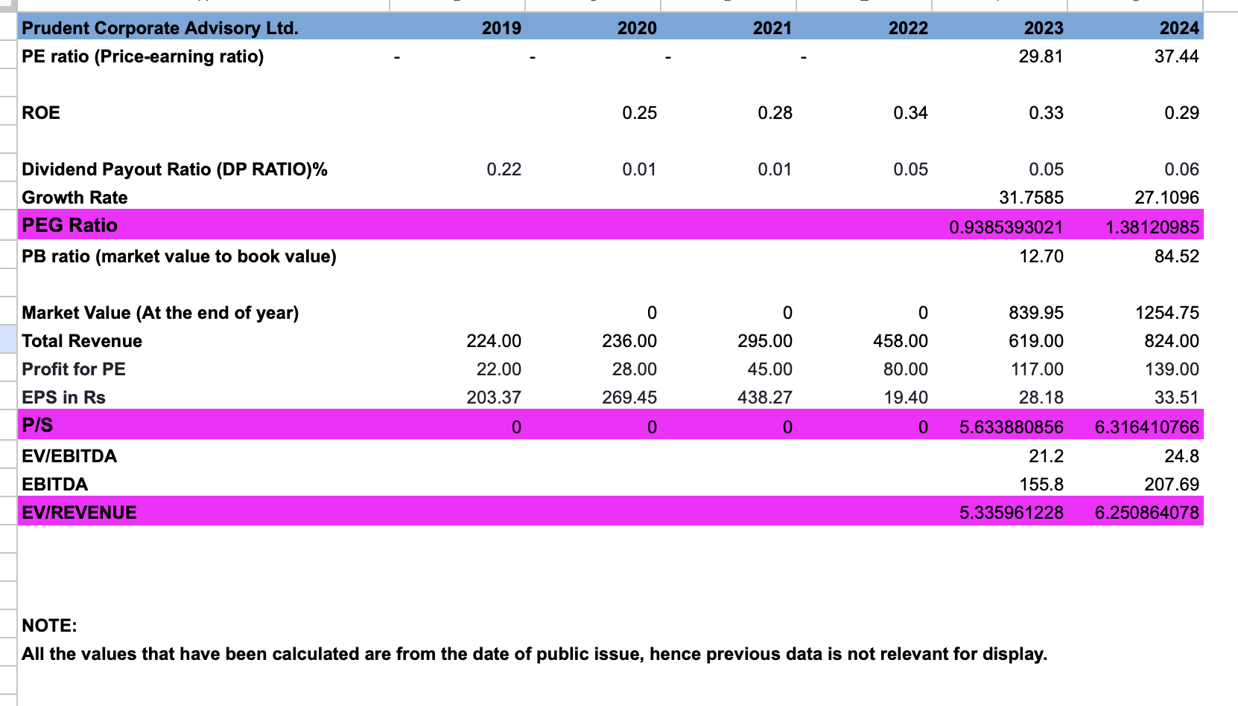
Prudent Corporate Advisory Services Ltd.
- P/E(37.44), PB(84.52), P/S(6.32), Ev/ Revenue(6.25) are overvalued.
- EV/EBITDA(24.8) is Overvalued.
- PEG ratio(1.38) has become significantly overvalued 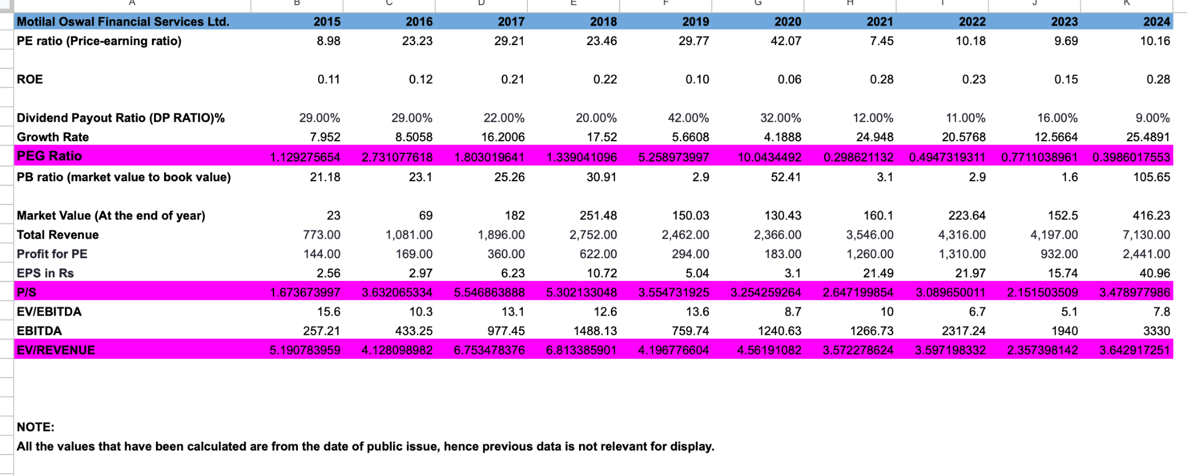
Motilal Oswal Financial Services Ltd.
- PB ratio was performing just at par except for an exponential rise in the last year to 105.65.
- EV/REVENUE(3.64) is significantly overvalued
- EV/EBITDA(7.8) is Undervalued.
- The P/E ratio is 10.16, which is at par with the industry
- PEG is 0.398, which is significantly undervalued.
- P/S(3.48) is slightly overvalued.

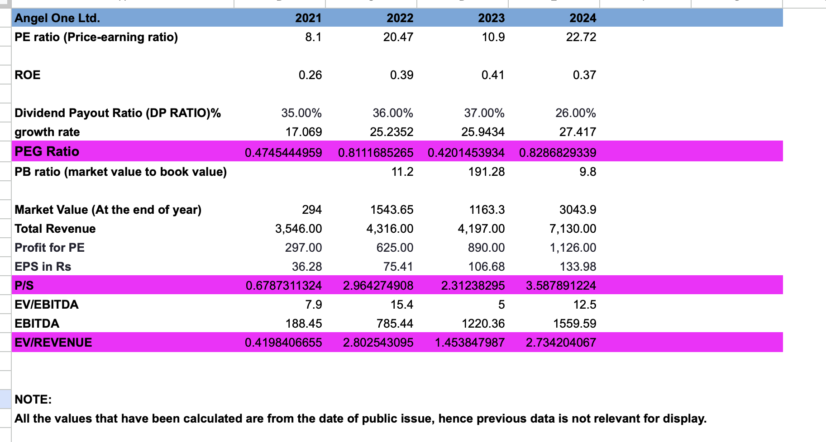
Angel One Ltd
*All ratios are calculated by making various assumptions, which may differ from the exact figures provided online.

- P/E(22.72) is overvalued,
- PB(9.8) is Overvalued above 2 times the Industry average
- P/S(3.58) , EV/REVENUE(2.73) is at par with Industry average
- EV/EBITDA(12.5) , PEG(0.82) is undervalued

References

- https://www.business-standard.com/companies/news/brokerage-firm-groww-cements-top-spot-with-nearly-a-quarter-market-share-124041500796_1.html
- https://www.motilaloswalgroup.com/Downirvirdir/257189515MOFSL-Annual-Report-FY-2023-24.pdf
- https://www.valueresearchonline.com/stories/50805/prudent-corporate-advisory-services-ipo-how-good-is-it
- https://finance.yahoo.com/quote/MOQUALITY.BO/
- https://finance.yahoo.com/quote/PRUDENT.NS/
- https://finance.yahoo.com/quote/ANGELONE.NS/
- Palepu, Healy & Bernard, Business Analysis & Valuation - Using Financial Statements, Text & Cases, Cengage Learning Publisher, 3rd Edition.
- Damodaran, Damodaran on Valuation, Wiley India Pvt. Ltd. 2nd Edition
- https://www.screener.in/company/MOTILALOFS/consolidated/
- https://www.screener.in/company/ANGELONE/consolidated/
- https://www.screener.in/company/PRUDENT/consolidated/
- https://in.investing.com/equities/motilal-oswal-financials
- https://in.investing.com/equities/angel-broking-ltd
- https://in.investing.com/equities/prudent
- https://www.nseindia.com/get-quotes/equity?symbol=MOTILALOFS
- https://www.nseindia.com/get-quotes/equity?symbol=ANGELONE
- https://www.nseindia.com/get-quotes/equity?symbol=PRUDENT
- https://www.bseindia.com/stock-share-price/motilal-oswal-financial-services-ltd/motilalofs/532892/
- https://www.bseindia.com/stock-share-price/angel-one-ltd/angelone/543235/
- https://www.bseindia.com/stock-share-price/prudent-corporate-advisory-services-ltd/prudent/543527/
- https://www.moneycontrol.com/news/business/startup/kunal-shah-to-take-on-zerodha-groww-cred-owned-spenny-applies-for-stock-broking-licence-12868041.html
- https://macabacus.com/valuation/dcf-terminal-value
- https://corporatefinanceinstitute.com/resources/valuation/what-is-terminal-growth-rate/

